Name: Farel Arden

Student ID: 001201900068

- The answer:

  - Data: are units of individual information
Examples of Data: Images, Words, Numbers

  - Information: are facts that are provided or earned from something or someone
Examples of Information: Odd numbers, even numbers, your friend’s address

  - Database: is an organized collection of data
Examples of Database: Library Database, University Database, School Database

  - DBMS: is a software package designed to manipulate, retrieve, and manage data in a database
Example of DMS: IBM DB2, Microsoft Access, Microsoft Excel

- The answer:

- Data Modeling is the process where we create data models that will be stored in the Database, why we need data modeling? because data modeling designed data in database so that they are accurately represented, because of this data modeling, it can help to create a logical concept of a database, it also can help to defines data relation, so data modeling can also help the user identify the missing data and it is easier to maintain the database.

- The basic data-modeling building blocks are:

  - Entities

  - Attributes

  - Relationship:
- One-to-Many
- Many-to-Many
- One-to-One

  - Constraint

- Business rules are statements which determine some form of constraint on a specific aspect of the database, a business rules make up some relation of aspects of the database.

For example:

“A ship date cannot be prior to an order date for any given order”

That is one of the examples of business rules, customers have to order first, after that they can have their ship date, it cannot be the opposite, this business rule gives birth to a relation of ship date and order date which its relation has already explained.

Business rules also become a communicator tool between the user and the designer itself

- The database evolution model happened in four waves:

  - The first phase(1960-1999), the development is known as hierarchical model, inverted list, and network model

  - The second phase was described as relational as was started about the 1990s, in this phase, SQL and SQL products were introduced

  - The third phase supported Online Analytical Processing (OLAP), which also started in the 1990s

  - In the fourth phase, the introduction of NoSQL in 2008, in this phase also supports the use of Big Data, nonrelational data, and graphs.

  - The data models:

        - Hierarchical Model→ Formed by a collection of relations, so they look like a family tree

This model is very simple, but its implementation is complex, it is very simple that the changes can change into a butterfly effect, which means when we change one aspect, it can change the entire structure of database.

        - Network Model→ This model is like a collection of links and handles many-to-many relation unlike its parent, hierarchical Model

This model is also simple, just like its parent, but the complexity of the pointers written in the model makes the model seems very complex and it is hard to change it. This model is like its parent, there are some anomalies and changes when you have to change certain aspects.
        - Relational Model→ This model groups data into one or more tables.

Unlike its parents, network and hierarchical model, this model doesn’t have any issues when you change one aspect, the changes don’t affect the complete database, but this model is inefficient when the model has large volumes of data and it does need powerful hardware and devices.

        - ERD Model → This model uses a graphic representation of a model database components

This model has a very good visual design and it is very simple and more enjoyable to see than the others, and also like the relational model, one changes do not affect the entire database system, and also it is efficient when handling large volumes of data.

But its simplicity comes with a cost, it has limited constraints and relations.

- The answer:

    - The new tables:

      - Journal

PK: JOURNAL_NUM

FK: PROF_OFFICE

      - Professor

PK: PROF_OFFICE

FK: None

      - Advisor

PK: ADV_NUM

FK: PROF_OFFICE

      - Committee
PK: COMMITTEE_NUM

FK: PROF_OFFICE
      - Department
PK: DEP_CODE
FK: None
b) ERD Database

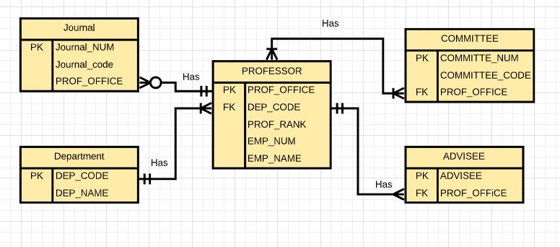

- These pictures show that all tables conform to 3NF Table name: Journal
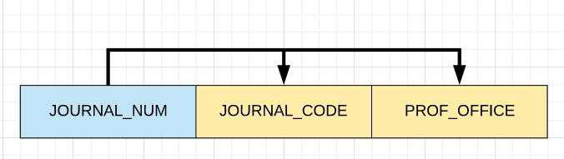

Table name: Committee
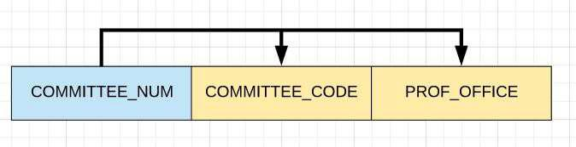

Table name: Advisor

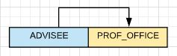

Table name: Department
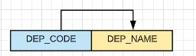

Table name: Professor

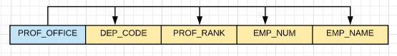

The arrows above shown desirable dependencies (based on PK)

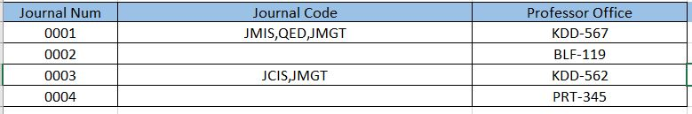
- These are the tables for the ERD system Table name: Journal

Table name: Professor

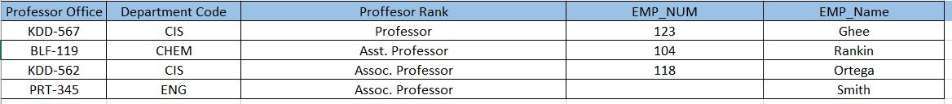

Table name: Advisor

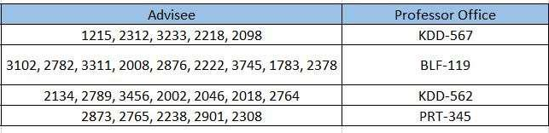

Table name: Committee

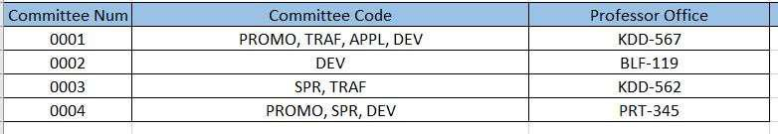

Table name: Department
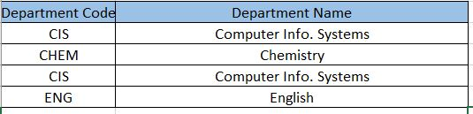

- The answer:

  - The new Tables:

    - Visitors PK: Vis_ID FK: None

    - Borrow Details PK: Borrow_ID FK: Book_ID,Vis_ID

    - Return Details PK: Return_ID

FK: Book_ID, Vis_ID

    - Books

PK: Book_ID

FK: None

  - row Foot Table

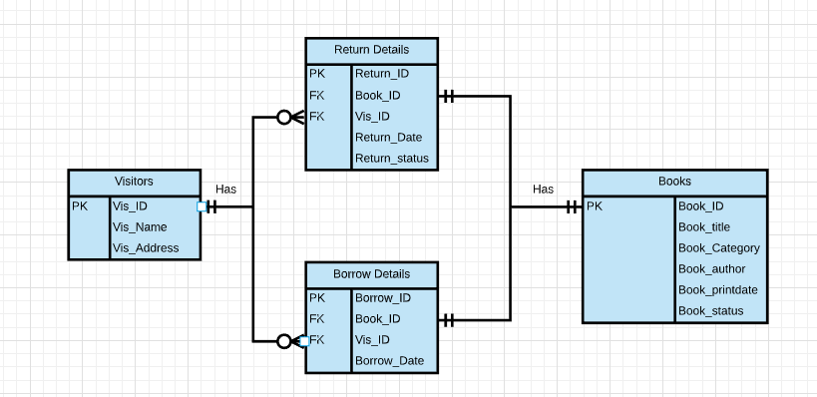

- These pictures show that all tables conform to 3NF Table name: Visitor
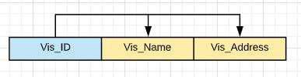

Table name: Borrow Details
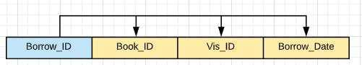

Table name: Return Details
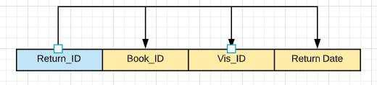

Table name: Books

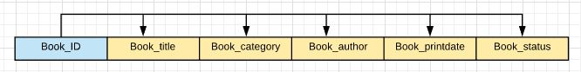

The arrows above shown desirable dependencies (based on PK)
d) The table for the ERD system
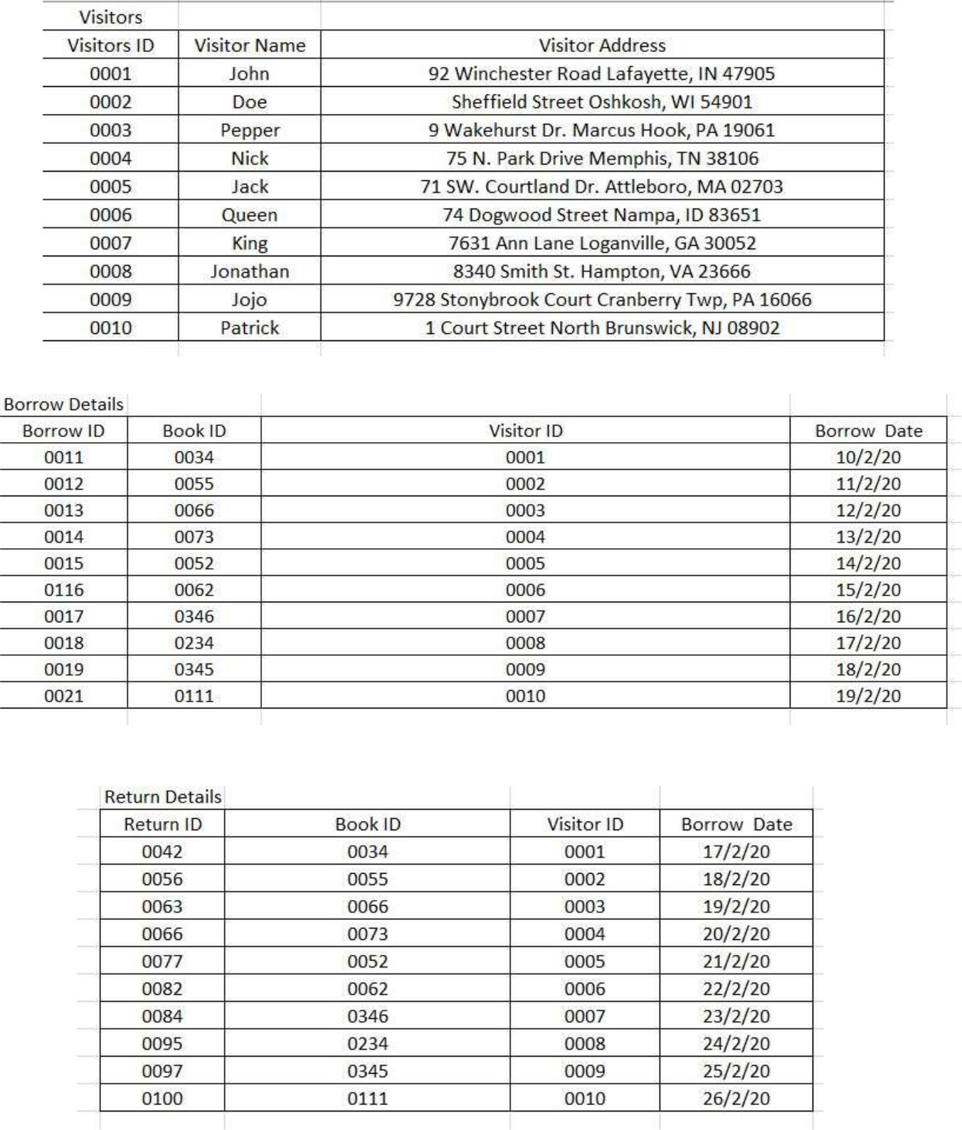
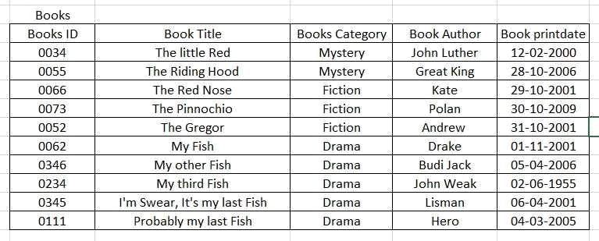
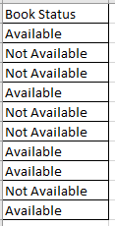

- The answer:

  - The new tables:

    - Lecturer PK: ID FK: None

    - Course

PK: Course_ID

FK: ID

  - Crow Foot Table

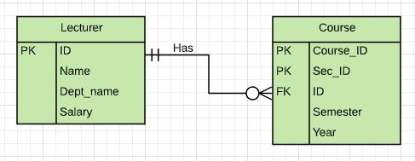

- These pictures show that all tables conform to 3NF Table Name: Lecturer
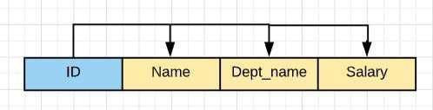

Table Name: Course
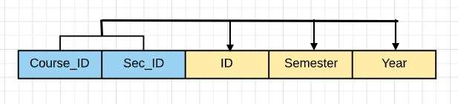

The arrows above shown desirable dependencies (based on PK)

d) The table for the ERD system
